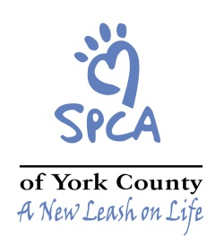

SPAY/NEUTER TRANSPORT

Transporter’s Name:_______________________ Transporter’s Phone: _________________

Name of Caretaker: _______________________ Caretaker’s Phone: ____________________

Address of Caretaker: _______________________

_______________________

All cats will go through the York County SPCA Spay-Neuter Surgical Center SOS Program. All cats will receive a one-year rabies vaccination and an ear tip for identification. Please note that your cats should be re-vaccinated for rabies after one year. You will be provided with more detailed discharge instructions and a copy of the Rabies certificate when your cat(s) is/are returned to you. If the veterinarian finds any abnormalities on physical exam (wounds, infections, parasites, etc.), you will be contacted to see if you wish to treat these findings for an additional charge. If you cannot be reached, no additional treatment will be performed.

Number of cats: _________________

Please read and sign the following:

I am the owner/caretaker for the above referenced animals and have the authority to execute this consent. I understand that unforeseen conditions may necessitate an additional or different procedure(s) in the professional judgment of the attending veterinarian. I also authorize the use of appropriate anesthetics and medications deemed necessary by the attending veterinarian. I understand that surgery has risks. The York County SPCA cannot be held responsible for these risks. Therefore I hereby hold the York County SPCA harmless regarding any and all liability that may be associated with these procedures. I do consent to authorize spay or neuter of the above referenced animals. The cost for this service is $20 per cat.

________________________________________
Owner/Caretaker

________________________________________
Date

Thank you for supporting the York County SPCA and for having your pets and local free-roaming cats spayed or neutered!

